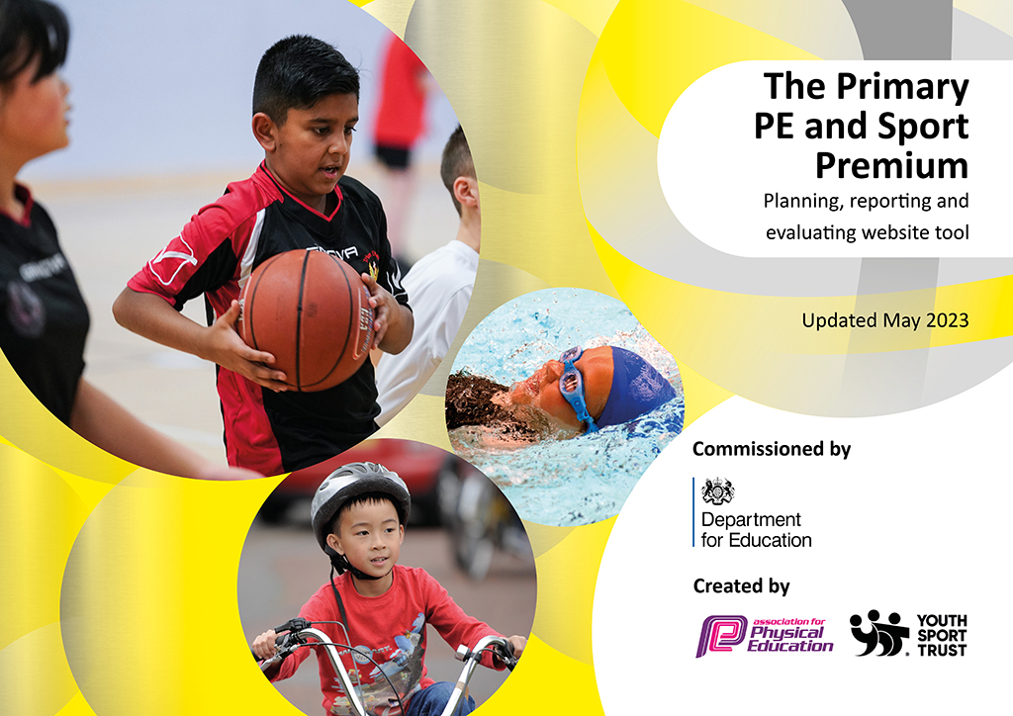
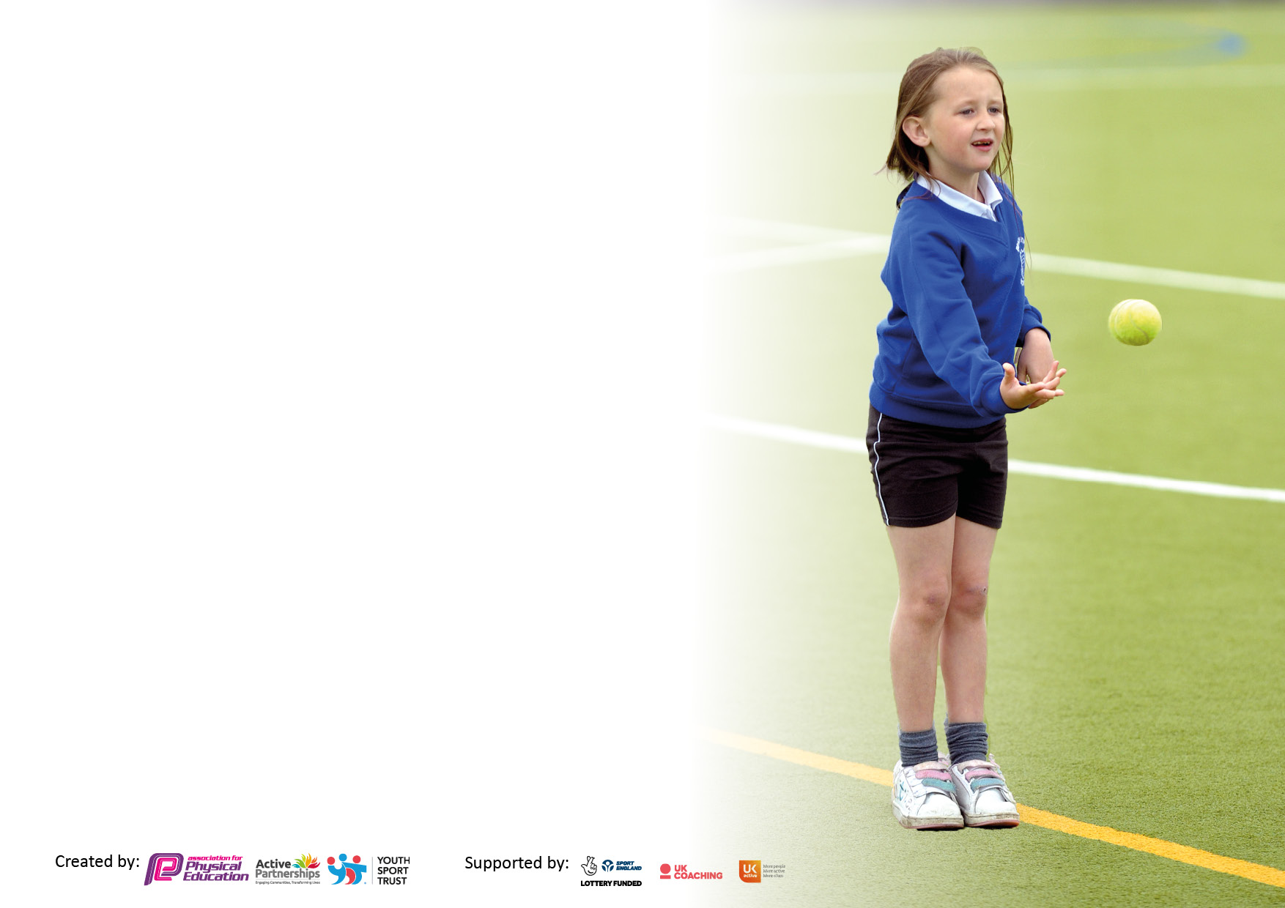

It is important that your grant is used effectively and based on school need. The Education Inspection Framework makes clear there will be a focus on ‘whether leaders and those responsible for governors all understand their respective roles and perform these in a way that enhances the effectiveness of the school’.

Under the Quality of Education Ofsted inspectors consider:
Intent - Curriculum design, coverage and appropriateness
Implementation - Curriculum delivery, Teaching (pedagogy) and Assessment
Impact - Attainment and progress

To assist schools with common transferable language this template has been developed to utilise the same three headings which should make your plans easily transferable between working documents.

Schools must use the funding to make additional and sustainable improvements to the quality of Physical Education, School Sport and Physical Activity (PESSPA) they offer. This means that you should use the Primary PE and sport premium to:

- Develop or add to the PESSPA activities that your school already offer
- Build capacity and capability within the school to ensure that improvements made now will benefit pupils joining the school in future years
- The Primary PE and sport premium should not be used to fund capital spend projects; the school’s budget should fund these.

Please visit gov.uk for the revised DfE guidance including the5keyindicatorsacrosswhichschoolsshoulddemonstrate an improvement. This document will helpyoutoreviewyourprovisionandtoreportyourspend.DfEencouragesschools to use this template as an effective way of meeting the reporting requirements of the Primary PE and Sport Premium.

We recommend you start by reflecting on the impact of current provision and reviewing the previous spend.

Schools are required to publish details of how they spend this funding, including any under-spend from 2021/2022, as well as on the impact it has on pupils’ PE and sport participation and attainment. The funding should be spent by 31st July but the DfE has stated that there will be no clawback of any unspent money so this can be carried forward into 2023/24.

We recommend regularly updating the table and publishing it on your website throughout the year. This evidences your ongoing self-evaluation of how you are using the funding to secure maximum, sustainable impact. Final copy must be posted on your website by the end of the academic year and no later than the 31st July 2023. To see an example of how to complete the table please click HERE.

Details with regard to funding
Please complete the table below.

Total amount carried over from 2021/22 | £0
Total amount allocated for 2021/22 | £16,970
How much (if any) do you intend to carry over from this total fund into 2022/23? | £0
Total amount allocated for 2022/23 | £16,860
Total amount of funding for 2022/23. Ideally should be spent and reported on by 31st July 2023. | £16,860
Swimming Data
Please report on your Swimming Data below.

Meeting national curriculum requirements for swimming and water safety.

N.B. Complete this section to your best ability. For example you might have practised safe self-rescue techniques on dry land which you can then transfer to the pool when school swimming restarts.
Due to exceptional circumstances priority should be given to ensuring that pupils can perform safe self rescue even if they do not fully meet the first two requirements of the NC programme of study
What percentage of your current Year 6 cohort swim competently, confidently and proficiently over a distance of at least 25 metres?  N.B. Even though your pupils may swim in another year please report on their attainment on leaving primary school at the end of the summer term 2023.  Please see note above | 88%
What percentage of your current Year 6 cohort use a range of strokes effectively [for example, front crawl, backstroke and breaststroke]?  Please see note above | 88%
What percentage of your current Year 6 cohort perform safe self-rescue in different water-based situations? | 88%
Schools can choose to use the Primary PE and sport premium to provide additional provision for swimming but this must be for activity over and above the national curriculum requirements. Have you used it in this way? | Yes, extra lessons and family passes for least confident swimmer

Action Plan and Budget Tracking
Capture your intended annual spend against the 5 key indicators. Clarify the success criteria and evidence of impact that you intend to measure to evaluate for pupils today and for the future.

Academic Year: 2022/23 | Total fund allocated: £16,860 | Date Updated: July 2023
Key indicator 1: The engagement of all pupils in regular physical activity – Chief Medical Officers guidelines recommend that primary school pupils undertake at least 30 minutes of physical activity a day in school |  |  |  | Percentage of total allocation:
 |  |  |  | 87.5% (£14,775)
Intent | Implementation |  | Impact
Your school focus should be clear what you want the pupils to know and be able to do and about  what they need to learn and to  consolidate through practice: | Make sure your actions to achieve are linked to your intentions: | Funding allocated: | Evidence of impact: what do pupils now know and what can they now do? What has changed?: | Sustainability and suggested next steps:
All year 6 pupils to swim at least 25m.  High quality P.E. sessions for all to engender competence, discipline and reflection.  Continue to thread healthy lifestyles through planning and teaching including a programme of fitness sessions to continue to improve physical and mental health. | Swimming lessons:  Y5/6 – Autumn 1 (6 weeks)  Y3/4 – Autumn 2 (6 weeks)  Additional safe self-rescue – Summer term  Programme of specialist P.E. providers for curricular P.E.  Hire of village hall to increase useable indoor space.  Hire of village hall field to increase useable outdoor space.  Golden Mile fitness assessment.  Sport and fitness provision provided by Premier Sports.  Mindfulness and Yoga (staff led clubs at playtimes) | £1,500  £5,850  £3,000  £1,000  £450  £2,975  £0 | 88% of Y6 pupils can swim at least  Least able swimmers attended extra lessons.  Sports equipment audited and replaced/enhanced where necessary.  Pupil questionnaires re: provision  Askwith fitness assessment created and children regularly assessed.  Fitness and teambuilding skills provided during playtime (Monday and Thursday) for all | Quickly identify less able swimmers re: extra provision.  Provide family passes for those identified.  System of replacing/enhancing equipment to continue 2023-2024  Continue to assess fitness – target classes
Key indicator 2: The profile of PESSPA being raised across the school as a tool for whole school improvement |  |  |  | Percentage of total allocation:
 |  |  |  | 11% £1,895
Intent | Implementation |  | Impact
Your school focus should be clear what you want the pupils to know and be able to do and about  what they need to learn and to  consolidate through practice: | Make sure your actions to achieve are linked to your intentions: | Funding allocated: | Evidence of impact: what do pupils now know and what can they now do? What has changed?: | Sustainability and suggested next steps:
Continue to seek the views of the children and parents re: after school sports provision and adapt accordingly.  Further develop enhancements timetable to provide greater opportunities re: a wider range of sports. Continue to reduce gender stereotyping through visitors | Programme of specialist P.E. providers for after school provision.  Invite a range of visitors – protected characteristics considered. | £1,295  £490 | Questionnaires to parents and children re: sports club provision.  Timetable altered to accommodate preferences where appropriate.  Sports for Champions scheme –presentation and workshop with Yorkshire basketball player Danny Evans. | Continue to question parents and children re: after school club provision.  Continue with Sports for Champion scheme.

Key indicator 3: Increased confidence, knowledge and skills of all staff in teaching PE and sport |  |  |  | Percentage of total allocation:
 |  |  |  | 1.7% £300
Intent | Implementation |  | Impact
Your school focus should be clear | Make sure your actions to | Funding | Evidence of impact: what do | Sustainability and suggested
what you want the pupils to know | achieve are linked to your | allocated: | pupils now know and what | next steps:
and be able to do and about | intentions: |  | can they now do? What has
what they need to learn and to |  |  | changed?:
consolidate through practice:
Staff are confident leading a wide range of disciplines  PE leader has up-to-date knowledge. | Ongoing CPD sessions to ensure staff are more confident in a wide range of disciplines.  Coaching course | £0  £300 | All staff confident to team teach alongside Premier Sport coach (year B units of knowledge)  Specific CPD with Premier Sports | Continue with CPD 2023-2024 new year A units of knowledge  Continue with CPD
Key indicator 4: Broader experience of a range of sports and activities offered to all pupils |  |  |  | Percentage of total allocation:
 |  |  |  | 0% £0
Intent | Implementation |  | Impact
Your school focus should be clear | Make sure your actions to | Funding | Evidence of impact: what do | Sustainability and suggested
what you want the pupils to know | achieve are linked to your | allocated: | pupils now know and what | next steps:
and be able to do and about | intentions: |  | can they now do? What has
what they need to learn and to |  |  | changed?:
consolidate through practice:
Additional achievements:  Children have experiences/opportunities for engaging in a wider range of sports.  Continue to encourage more pupils to engage in independent/structured activities at playtime. | Continuation of new P.E. units: multi-skills, invasion games, dance and gymnastics, athletics and strike and field skills.  After school provision to include: football, rugby, gymnastics, hockey, tennis, cricket, archery, Tchoukball/bench ball, fencing, table tennis.  All staff trained by PE lead on promotion of physical activity at playtimes.  Continued encouragement through assemblies, family groups, class representatives and staff on duty. | Included within indicator 2  Included within indicator 2  £0 | New units of knowledge (year B) are embedded – children given opportunity to deliberately practice skills across a range of disciplines  Pupil questionnaire re: provision undertaken and timetable amended  Games during playtime including all children  Upper KS 2 children lead own team games/team building activities during playtime including all children | Embed new year A units of knowledge – highlight opportunities to deliberately practice skills  Continue to question children re: provision  Continue in 2023-2024

Key indicator 5: Increased participation in competitive sport |  |  |  | Percentage of total allocation:
 |  |  |  | 0% £0
Intent | Implementation |  | Impact
Your school focus should be clear | Make sure your actions to | Funding | Evidence of impact: what do | Sustainability and suggested
what you want the pupils to know | achieve are linked to your | allocated: | pupils now know and what | next steps:
and be able to do and about | intentions: |  | can they now do? What has
what they need to learn and to |  |  | changed?:
consolidate through practice:
Continue to develop inter/intra school competitions with the aim of achieving Silver Sports Award. | Silver Sports Award in progress.  Timetable of one-off and end of unit sports competitions.  Participate in a greater number of inter-school competitions  Signpost and encourage increased participation in extra-curricular competitions. | £0 | Silver Sports Award – ongoing evidence gathering  End of unit sports competitions continue – winning sports house announced termly.  Limited inter-school competitions  Extra-curricular clubs outside of school signposted for all children using weekly newsletter and club fliers. | Continue with intra-school competitions.  Greater opportunity for inter-school competitions in light of reduced restrictions.  Continue 2023-2024

Signed off by
Head Teacher: | E. Nayler
Date: | 15.07.23
Subject Leader: | O. Mort
Date: | 15.07.23
Governor: | N. Muttick
Date: | 20.07.23

